

Hector MacAndrew 1903 – 1980

With This Website

# [www.scottishfiddlemusicinstyle.co.uk](http://www.scottishfiddlemusicinstyle.co.uk)

# I remember with deep affection my teacher in this field:

# Scots Fiddle Player Hector MacAndrew

Feel free to copy the tracks for personal listening and/or the text for study purposes - but having done so - please acknowledge the source.

Copying text or illustrations (which are copyright) for distribution to third parties or for commercial purposes should not be undertaken without permission.

Whilst effort has been made to indicate sources, and to give credit to individuals and organisations - where possible,

the texts (inclusive of historical data and my personal comments) are included to furnish ideas for anyone wishing to undertake more

in-depth exploration.

Queries: Please email [michaelr.welch@btinternet.com](mailto:michaelr.welch@btinternet.com)

No 32 10th July, 2025

________________________________________________________________________________

**Tunes from my collection - from which I play frequently.**

**My ‘favourite’ will be the one I’m playing…**

***N.B. Where Gaelic is quoted in a track title or text – this is taken directly from the source utilised***

***\*\*\*\*\*\*\*\*\*\*\*\*\*\*\*\*\*\*\*\*\*\*\*\*\*\*\*\*\*\*\*\*\*\*\*\*\*\*\*\*\*\*\*\*\*\*\*\*\*\*\*\*\*\*\*\*\*\*\*\*\*\*\*\*\*\*\*\*\*\*\*\*\*\*\*\*\*\*\*\*\****

**01)**  **2/4 March: The Balmoral Highlanders**

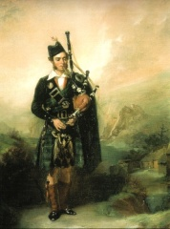

Angus MacKay (1815-1859)

Piper to Queen Victoria 1843-1853

(Scottish National Portrait Gallery)

*‘Angus MacKay, a major figure in the known history of the Great highland Bagpipe, painted by Alexander Johnston in 1837 when piper to Campbell of Shawfield and Islay. He is playing the Prize Pipe won in the Highland Society Competition of 1835’.* See *Bagpipes,* by ProfessorHugh Cheape, NMS Enterprises, 2008, p.57.

The chapter on the *Traditional Origins of the Piper Dynasties* in the above book illustrates the prestigious piping coterie from which Angus MacKay descended - the culture in which the music of the ceòl-mór flourished.

This 2/4 march is ‘light’ music - functional - and the *Balmoral* would suggest composition during his service period within the royal household...

It is a bright lively march - the *double tonic* structure (the tune dropping a tone from the original pitch and then returning again) - which Francis Collinson (1966) mentions, is well illustrated! There will always be ‘borrowings’ when it comes to this music - not always deliberate. It has to be said with only nine notes at your disposal on the chanter, as a composer, you have to be imaginative and also, given continuous drones, mindful of the tune construction so as to produce an elevated emotional impact.

**02) Strathspey & Reel: The Braes of Mar; Bruce of Kinnaird's Reel**

Here are two pipe versions (arranged for fiddle). Firstly from the William (Uillium) Ross Collection, the first edition of which appeared in 1869, and secondly from the David Glen Collection Book 12, in which the reel is presented following on. The origin of the strathspey is obscure. There are several versions for pipes, fiddle and also song adaptations. In addition there may also be a prior Irish connection. The reel is possibly named after Sir James Bruce of Kinnaird (1730-1794) but I have so far been unable to confirm this.

**03) Air: Calum Ban’s Soldier (Saighdear Chaluim Bhain)**

Remembered as ‘The Soldier Son of Calum Ban’. This arrangement (where I begin and end with the ‘chorus’) was inspired by the singing of Mary Smith. It will be found on her CD *Sgaith Airgid* (track eight). Mary learned this song during her school days I believe. Fortunately for us. It is a highly evocative song. The pain of separation is tangible… ‘O how sorrowful I am/Watching the grass grow/As it hides your footprints… Will you come to see me this year/Or will you never come...’ There is a ‘chorus’ and eight verses. The accompanying booklet has Gaelic words and an English translation (from which the above quote is drawn). Whenever I play this tune I can’t but think of its relevance in today’s world.

**04)** **Air: The Bonny Scotch Lad**

The fiddle arrangement for this song was transcribed from the singing of Geoff Lawes courtesy of the Yorkshire Garland Group to whom I am grateful for allowing me to use it in this way.

Geoff's singing was recorded in Hull on 24th July, 2007, accompanying himself with concertina.

It has to be said that a transcription of this nature requires close attention to the subtle variations in the melody required to comply (a) with the sentiment and (b) rhythmically, with the words. Furthermore, this is one performance, and as with any recording the mould is cast forever. But live performances have the possibility to vary infinitely - the audience, the acoustic, the venue, the mood of the moment, jet lag, - a mix to colour the outcome.

Whilst this not strictly 'fiddle' music, nevertheless looking at the array of songs, both Jacobite and Whig, which flourished since c17, for example in James Hogg's two volumes (1819 & 1821), it is not rocket-size to imagine the adaptations made for dance music etc. from the wealth of all this material. In fact the exponential flourishing of the 'collections' from the late c18 onwards owed much to this substrata.

**05) S & R: The Source of Spey; Clanrannald’s Reel**

The strathspey, appearing in Simon Fraser's 1816 Collection (no.72), and according to himself, is a composition of Lachlan Macpherson, Strathmashie.

Strathmashie was once the residence of Lachlan Macpherson, the bard, the contemporary and coadjutor of James Macpherson, the author of clever Ossianic fiction. Now, whether this tune is by him I speculate. The rather haunting hexatonic format (EF#GABD) suggests it might be. Anyhow, SF says of it: 'This air was acquired by the Editor's grandfather from Lachlan M'Pherson of Strathmashy... He lived near the source of Spey, and it has every chance of being his composition, he was a genuine poet, and sung with taste and spirit'. Sound effects: trickling stream, female osprey. Hector played this for me on a number of occasions. We had a mutual regard for it.

The reel, of likewise construct, editing out the C# in bar one, I have from Niel Gow's Second Collection (second edition). 'Very old' is the only clue he's left us as to its origin. Given his background, he undoubtedly possessed a wide repertoire of airs and dance tunes with a Gaelic pedigree which would cast their spell over him, a fiddler lost in his playing, as Raeburn's portrait captures. The tune has a wild leaping structure, indicative of rugged terrain and/or historical clan activities**.**

**06) Air: Shall I Never Return**

This setting for the fiddle was inspired by the singing of Seonag Niccoinnich, - Joan MacKenzie (1929-2007). There is a wealth of information on-line about her.

For example: the CD, no.19 in the *Scottish Tradition Series,* CDTRAX 9019, (a compilation of recordings made by both the School of Scottish Studies and the BBC) is spellbinding.

Of this song Joan has four verses, fifthly repeating verse one. As the text unfolds, she lives it. Close attention to the articulation of the Gaelic words and breath control will reveal how an extraordinary command of expression is enabled. Melodically all the verses are inevitably different (but contained within the broad structure of the tune).

The song is by one Calum MacLeod from Carloway, Lewis. Unfortunately, in the booklet accompanying the CD there is no English translation from which, as Captain Fraser so eloquently puts it ‘the substance may be gathered’. I am very grateful to Morag MacLeod for sending me a translation to enable this. Calum composed the song whilst living in Detroit in 1925. It begins:

*‘Shall I never return to the glens where I was young…’*

Well, he had prospered sufficiently to have the means for a return journey. His homecoming wish was fulfilled before he was gathered to his fathers. He is buried in Dalmore cemetery, a burial ground at the head of a sandy bay, *Bagh Dhall Mor*, a silent (apart from the sounds of shore) space, not far from his birthplace, open to the northwest and the Atlantic Ocean. Whilst this song is specific, in a broader more universal sense ‘Homecoming Scotland’ takes on a different connotation for many people down the centuries - through turbulent history – each one with their own story…

**07) Slow S & Reel: The Duchess of Buccleuch; Mrs Charles Stewart, Pittyvaich**

The slow strathspey genre is far removed from the music of the Scottish Western Highlands or Islands, Piobaireachd, port-a-beul (mouth music) for work or dance i.e. the ‘strathspey reel'.

This idiom, with its predictable European harmonies and mostly 16-bar format is ballroom/drawing room listening for the lords, ladies and gentlemen, a format exemplified in spectacular fashion by William Marshall (b. Fochabers,1748, d.Newfield Cottage near Craigellachie Bridge,1833) by all accounts a gifted, self-taught, fiddle player whose curiosity, intelligence, sensibility and patient application to the task at hand, together paid dividends in several fields outside music. Although - euphemistically - 'below stairs', William was well placed in the Gordon household (Gordon Castle) to develop his talents, which he did with grace and tact, serving the rather quiet sensitive 4th Duke of Gordon (1747-1827) on the one hand, and his extrovert, lively wife, Jane Maxwell, 'The Flower o' Galloway', on the other - often a topic for examination during my sessions with Hector.

Moyra Cowie's book *The Life and Times of William Marshall* thoroughly documents his life. An mechanical artefact of William's own making, a splendid grandfather clock, is on view to all in the Fochabers museum. The tune *The Duchess of Buccleuch* was so named for Lady Charlotte Anne Thynne, who married the fifth Duke of Buccleuch in 1829 and it appears in Marshall's 1845 (posthumous) collection, as does the reel *Mrs Charles Stewart, Pittyvaich.* Members of the Stewart family, tenant farmers on the Dufftown estate, are named in a number of William's compositions.

**08) 6/8 Jig: The Herring Wife (Caillach nan Giuran)**

A lively jig from the *William Gunn Collection*  which to me evokes the bustling herring industry (when there was one) - harbours, fish, drifters, nets, barrels, gutting one-a-second fisher lasses, sellers, buyers, heavy weather, sea mist, fog horn, diversions after the day’s toil etc...

This setting is found in the *William Gunn Collection of Pipe Music* reprinted by the National Piping Centre, Glasgow, with a Foreword by Finlay J Macdonald, 2003. The original edition appeared in 1848 and there were several subsequent revised reprints. William was born in Sutherland c.1788 and was a Gaelic speaker - in fact the tunes are named firstly in Gaelic and then English.

**09) Air: Sorrowful Am I**

This beautiful *waulking song* air I have arranged as a slow air/lament. The tune is Dorian (DEFGABCD). It is sourced from *Hebridean Folk Songs, Volume III*, John Lorne Campbell/Francis Collinson. These three volumes are a constant source of inspiration and wonder, connecting me with a boundless, ever changing soundscape of moods of sea and sky and the human condition in which they may serve as a metaphor. This culture was remarkable in its robust address to a life in the Hebridean environment, geared to the cycle of turning years. Waulking (a method of shrinking woven cloth) was one of the activities which inspired many songs and variants thereof.

**10) Reel: The Little Cascade**

Not, as the title might suggest, anything to do streams or waterfalls but rather with a DIYer’s nightmare - the nagging, dripping/dribbling tap. Don't wait for it to go away itself… its defined by an algorithm of epic proportions… tending toward the upper end of chaos theory…? P/M G.S. McLennan had his own musical take, inspired by the sound of water dripping randomly from a tap into a tin basin. Such was the man’s imagination and his technical prowess to achieve the resulting composition – use of pentatonic scales and syncopation, ornamentation etc.

This is my adaptation for the fiddle.

(Always turn the water off, by the way, before attempting tap repairs).

**11) 9/8 Slip Jig: The Heroic Lad**

- or *Gill’ in Gill’ Odhar* in the *William Gunn Collection*, 1848, (p.50) – see also track 8) above. In a 9/8/ rhythm there are three beats of three pulses. It is of course a rhythm common in Ireland. Again, the style is open to modification of tempo and stress (or both). Gunn gives no indication of origin. In the Foreword to the reprinted edition (2003), Finlay Macdonald mentions Gunn’s date of birth - around 1788, in Sutherland, and that “it is believed he trained in weaving before moving to Glasgow during the Highland clearances”. Finlay Macdonald goes on to say that by the time of publication WG had already become familiar with eminent pipers of his day and a variety of styles and arrangements of tunes... So here we have an intriguing chemistry: Sutherland Gaelic, style, arrangements, rhythms, weaving...

Consequently it comes as no surprise that he would include a tune like this if it took its fancy

**12) Air: Tis Me That’s Happy**

A 'spirited' air from Celtic Melodies (Vol. 1, no.7) collected by Finlay Dun (1795 - 1853), musician, violinist, singer and composer.

Finlay was born in Aberdeen and after attending Perth grammar school and Edinburgh University continued his musical education and activities in Paris, Milan and Naples, returning finally to Edinburgh in 1829 and subsequently teaching violin and singing. The collections of Scottish songs and Gaelic airs, which he edited or co-edited, is the corpus by which he is perhaps best known nowadays.

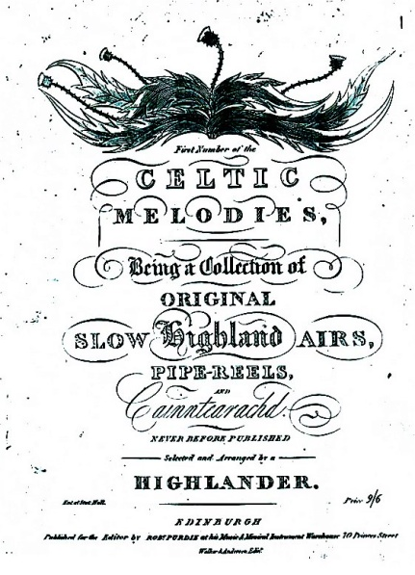

I currently have no words for the song but from the air alone it strikes me as lightsome-step, buoyancy and mischief...

**13) 2/4 March: Corriechollie’s Leaving Lochaber**

This tune, composed c.1908, by Pipe Major Robert Meldrum (1851-1941) whilst he

was piper to the Earl of Ancaster, Drummond Castle, honours one of the Camerons of Corriechollie - John Cameron of Corriechollie (d.1856) was in his time arguably the most famous cattle drover of his time. In order to identify him from other John Camerons he was named after his place of residence: *Corrichollie* (tr. *the glen of the forest*) in the Spean Bridge area. The ruined remains of his original residence lie some distance from the present lodge. John Meldrum from all accounts was a jovial strong spirited man. John Wilson writes of him (autobiography, 1978, *A Professional Piper in Peace War*) entering the *Open Piobaireachd* competition at Aboyne Highland Games in his early 80’s. ‘He was a wonderful old man and a fine player and very successful in his day’.

**14) Air: The Song Thrush of Clan Donald (Smeòrach of Chlann Domnaill)**

A song by John MacCodrum (Iain MacFhearchair) (1693-1779) who was born at Cladh Chomhghain, Aird an Runnair, on the west side of North Uist - [Brief Biography](https://en.wikisource.org/wiki/MacCodrum,_John_(DNB00)). In the song (alluding to the thrush)(1755) he quotes *'In Comgan's Churchyard was I born, in Aird an Runnair I was reared, in sight of the proud throbbing sea, of the sportive fickle playful waves'* - William Matheson's translation.

MacCodrum spoke for his people with such a singular, powerful voice that one can feel an almost tangible identity with that period of history.

The fact that he couldn't read or write - 'an unlettered man' - may seem quite foreign to us, but in his circumstances, it wasn't necessary. Memory was the ‘hard drive’ in an oral culture, - in song, in genealogy, in piping) - along with the impact his environment had on him. He was by all accounts a spirited, quick witted and sprightly man well into old age. You wouldn't have wanted to become the subject of one of his satires, by the way!

*The Songs of John MacCodrum*, *edited by* *William Matheson*, (Scottish Gaelic Texts Society, 1938) is the source for this song.

WM says that this song is derivative. It ‘*originally belonged to an old North Uist seal song… MacCodrum remodelled the chorus* [with which my arrangement begins] *in order to imitate the notes of the mavis’*.

The bards in those far off days were known as ‘the song thrushes of the clans’.

**15) Air: Mary the Daughter of George**

This track is an arrangement of no.3 in Captain Simon Fraser's 1816 Collection. His note is included in full:

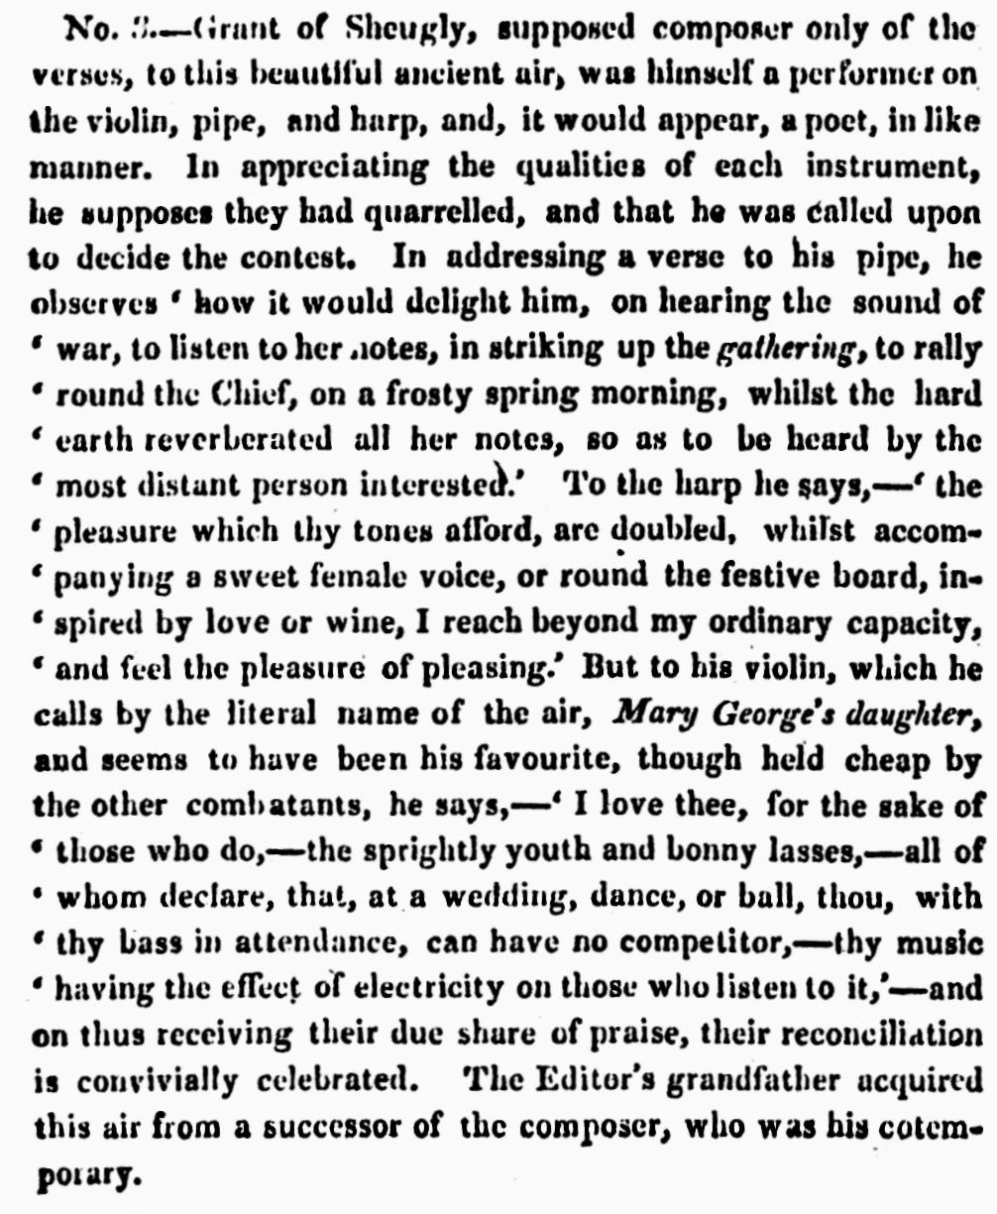

The note to tune 87 in Angus Fraser’s Collection *of the Ancient Music of Caledonia* relates as follows:

'The air to Mr Alexander McDonald of Ardnabi’s song in praise of his violin which he calls 'Mary George's Daughter' after a similar song made in the preceding century by Grant of Sheugly in Glen Urquhart on a supposed contest between the violin pipe & harp. See no.3 in Captain Fraser’s Collection of 1816 [see above]. There is a chorus of unmeaning words accompanied with music in the pizzicato style of the harp'.

Tantalizingly the music is missing - the archive mss is incomplete! There is a further version in Daniel Dow's (1732-1783) *A Collection of Ancient Scots Music for the Violin, Harpsichord or German Flute...* (?1778)

John G Gibson in his *Old and New World Highland Bagpiping* (2002) mentions that ... 'The Grant material, though skimpy, suggests that the mid-C17 marked the turning point from strings to woodwind. One well-to-do Grant, Grant of Sheugly who flourished... in the late C17 was himself a piper, harper and violin player. He composed the verses to 'Mairi Nighean Dheorsa' My backing has four sections: strings/pipes/harp/all.

**16) S & R: The Rocks of Cashel; The Geen (Wild Cherry) Tree**

### Both tunes arranged from Niel Gow’s (printed) Repository, Book II. Niel Gow (1727-1807) is a legendary figure in the annals of Scottish fiddle tradition. On the one hand rustic and pastoral and on the other able to translate much of the music he absorbed into the contemporary social ballroom scene, where he became very much in demand. Many ‘collections’ of tunes that he (and his family) played were in print from the late eighteenth century onwards and are a study in themselves into the way this music developed and adapted over the succeeding decades. A portrait of him (Raeburn) hangs in the Scottish National Portrait Gallery, Edinburgh, and another in the ballroom at Blair Castle. Duncan Macmillan (*Scottish Art 1460-1990*) says ‘…even more striking is the analogy between Raeburn’s *Niel Gow* and Reynolds’s remarkable portrait of *Joshua Sharp*. Both are pictures of someone intensely absorbed and turned inwards upon themselves…’

**18) 2/4 March: Donald Cameron**

This march should have vigour, vitality and courage. It's a good way to get the day started whilst waiting for the teabag to infuse.

Donald Cameron was born near Dingwall c1810. He showed propensity for the pipes at an early age. This subsequently blossomed under the tutelage of Big Donald MacLennan of Moy and later Angus Mackay and John Ban Mackenzie. Needless to say, with that pedigree he became a champion, particularly in the field of Ceol Mor (piobaireachd). He died at Maryburgh in 1868.

However, he wasn't the composer of the tune that bears his name. This accolade is usually ascribed to Hugh Mackay (1801-1864), brother of Angus and one-time Pipe Major of the Stirlingshire Militia.

Hugh was not renowned for his piobaireachd playing, but became a first rate composer of 'competition' marches. This tune appears to have been a joint effort (concocted when he and Donald were in residence at Stirling Castle concurrently) and where each contributed one or more of the parts, either from their own compositions or elsewhere... Oh! to have been a fly on the wall at that time, witness to this mischief...

Whatever, they have left us this splendid march of 'difficult' category for the pipes, and it has to be said not without technical issues for the fiddle either. On whatever instrument - the tune has to be mastered thoroughly before the intricate phrasing reveals its secrets.

<http://www.lochiel.net/archives/arch094.html> includes biographical material and DC's portrait in proud full highland dress!

**19 Air: The Marquis of Huntly**

Found printed in the 1781 edition of Marshall’s music as *The Marquis of Huntly’s Reel – a Strathspey,* and in the 1822 edition as *The Marquis of Huntly’s Strathspey.*

Having learned it thus, I played it over, quite confidently, to Hector during one of our sessions.

He gracefully listened to the whole performance, before wagging his finger and then playing it, very sensitively and persuasively, as a slow air. That was the path he chose, and the one I endeavour to follow. I pursue the hexatonic mode (no F# in bar 12). The violin chords are not struck but stroked, leaving the G and D strings to resonate. I cannot but help pondering over Marshall *first* introduction to fiddle playing, and then particularly with tempi and modality. Perhaps this tune revisits some of these early embedded resonances?

**20) Lament for the Children (Cumha na Chloinne) Cèol Mor Ground/Urlar**

Whilst John Playford (for example) was busy with his pretty tunes, circa 1651, at the same time another voice spoke for a remote oral culture on the North Atlantic rim of Europe. It spoke of war, of battles, the fiery cross, of heroes, of salutes, of marches, - and wept its laments, all in a way like no other instrument. I am referring to the Highland bagpipe, an instrument of the people of northern and western Scotland, remote in custom from London (as 'remote as Borneo' said Dr. Johnston later on).

I am alluding of course to 'piobaireachd' - this particular musical discipline and language ingrained in drones and a chanter of nine fixed notes, activated by a human being, blowing into a sheepskin bag - a bagpipe.

One of the foremost traditional piping families was Clan MacCrimmon *(MacCruimen),* who became hereditary pipers to MacLeod of MacLeod, their piping 'college' being established eventually at Borreraig, NW Skye, north of Dunvegan. Whilst the clan name (unique in Scotland) may be of Norse origin, the family were known in c.16. The clan member we are focussing on here is Pàdraig Mòr MacCrimmen, c1595 - 1670, Piper to the MacLeods 1640 - 1670.

It is believed this lament was composed sometime in the mid 1650's, legend has it, after the loss of seven of his eight children to smallpox, carried ashore by a visiting ship's crew.

Whatever stirred this man to create such a powerful piece, whether this loss (or as another theory suggests - post battle of Worcester in 1651) - seen in its cultural context it conveys an outpouring of grief like no other. There has also to be fortitude to overcome this - as Gaelic poet and writer Angus Peter Campbell puts it in a *Sunday Times* article 'When I hear Lament for the Children I detect courage at the heart of it'.

Perhaps MacCrimmon had a favourite practice place in that isolated part of Skye, enabling the echo of his own pipes from cliffs or a cave, almost a sacred place, where he could continue honing his own skills without being disturbed.

The music speaks to us as powerfully in c.21 as it did some 370 years ago.

Arranging the *urlar* (the slow movement on which the whole piece begins and turns) for the fiddle is not straightforward. To begin with the nine notes of the chanter scale do not correspond exactly with what our 'diatonic' ears might expect - each of those nine notes raises a particular emotional impact when combined with tenor and base drones - for which it is designed. Then there is the bewildering array of printed material and pipers' personal interpretations, both oral and instrumental. In the end, motivation to arrange this tune is tempered by compromise, and one has to sift away... and decide.

Open A and E strings (i.e. without vibrato) are prominent in the violin setting. This effect adds a colder ring of inevitability - this is deliberate. Such was MacCrimmon's depth of emotion and sorrow in coming to terms with his circumstance. As a musician of his race, it was a way of dealing with his condition and sharing it.

After the tune fades away please listen to the silence –

this ending is part of the performance…



MacCrimmon Memorial Cairn, Borreraig (near *Gob na Hoe)*

(Courtesy of Caledonian Mercury)

****************************************************************

Notes © Michael Welch, 10th July, 2025

****************************************************************