Hector MacAndrew

A Personal Memoir

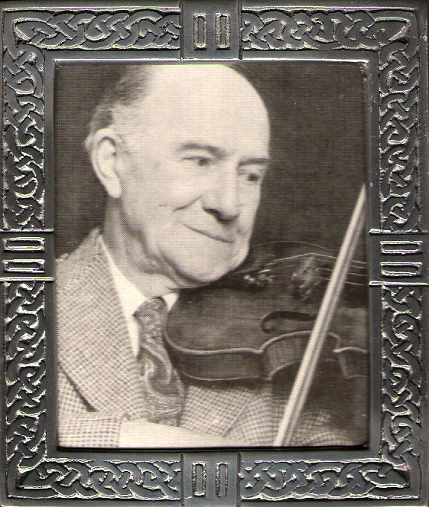
It was James Hunter (then a BBC Producer in Aberdeen) who first encouraged me, early in 1970, to meet Hector MacAndrew (1903-1980, left) and I thank him for that. I had heard archive recordings of Hector’s playing at the BBC and the School of Scottish Studies prior to this, and of course listened to his broadcasts but on sitting at his hearth and hearing him draw the bow I had no reason to look further.
I remember with gratitude the hours spent there, during the last decade of his life, times where we covered many aspects of his native fiddle music, from croft to ballroom, from campaign to fo’c’s’le…

The music evolved over centuries. Hector’s playing always seemed to have this sense of an historical vision behind it, as might be expected from a true ‘traditional’ performer – on any instrument, including the voice. The, for want of a better word, ‘classical’ training he received (and obviously made the most of) never to my mind blurred or diluted the aural references which he carried with him from his forbears. Quite the contrary, it enhanced them. It is this aural aspect that calls for close attention when listening to (any) archive material.

He began playing very early in life, before he went to school, inheriting the Niel Gow (1727-1807) mantle through his father Peter and grandfather, also Peter, the latter Hector said, was taught by a pupil of Niel, one James Macintosh of Dunkeld. It is also worthy of note that Hector’s great-grandfather, also Peter was born about the time Niel Gow died. Much background research has been undertaken on the Gow family and placed elsewhere in the public domain (for the curious the ubiquitous Google might be a good place to start). Suffice it to say there was doubtless much (unwritten) music in Strathbraan - where Niel spent his formative years - song, fiddle, pipes, clarsach(?). See Daniel/Donald Dow (1732-1783) a native of Kirkmichael, his Collection of Ancient Scots Music, published c1776. The point is – aural tradition, (canntaireachd) from a time prior to the tidal wave of AABB dance music breaking and leaving in its wake the band wagon of published volumes, the ballroom, the dance hall, the stage, and the music hall, and then 1822 and tartan packaging and a’ that…

Hector was always modest about his left-hand technique – the ornaments, sliding turns and mordents, double stopping and unisons, the latter crucial for emphasis in strathspey playing. I perceive these rooted in aural tradition and he always used them to good effect in the service of the music. The ornamental possibilities of the human voice (enhancing emotional expression) are infinite. Listen to a traditional Gaelic singer. So too on the fiddle string. As if this were not enough, add the right arm/wrist bowing ingredient, the flow, the momentary addition of speed and weight to the up-bow stroke (believed to be exceptional in Niel Gow’s case) generating the lift, the elegance and spirit of the strathspeys (dance and slow). This ingenious repertoire of bowing possibilities would be combined with tonal variation - not always playing the same tune exactly the same way twice in succession, for example.

Not only was he so well versed in this inherited fiddle style (from grandfather and father) but also there was in addition a piping dimension. The sound of the pipes, as well as the fiddle, would have been with him from day one. His father, Peter (b. Moulin, Perthshire, 1867) employed on the Fyvie Castle Estate, was piper to Lord Leith (this patronage the dying embers of a tradition reaching back centuries into the clan system). Hector loved the instrument, but he was not able to blow without suffering nosebleeds, he said.

Hector’s great-grandfather was employed at Taymouth Castle at a time when John Ban Mackenzie (1796-1864) was piper to the Marquis of Breadalbane. JBM, Hector said, taught his grand uncle who in turn taught his father piobaireachd.

Hector served with the Royal Artillery in North Africa during WW2. I imagined the homecoming when it was all over. Never would his native music have sounded sweeter. Perhaps cathartic, after such experiences, but we never talked about that time very much. Hearing regimental pipers during his war service I do know certainly moved him deeply. March playing may be viewed from a very different perspective in these circumstances. What is it for? One reflects.

He enthused about contemporary pipers as well as some of the nineteenth and early twentieth century players and composers. I mention only three: Angus MacKay, G.S. McLennan (a particular favourite) and William Lawrie. The first pipe march he gave me was the latter’s Mrs MacDonald of Dunach. We were by the fire in his cottage when someone came to the door. So the flow continued upstairs, along with reel-to-reel tape recorder. The tape was not bedded properly, but I cherish the scratchy recording, which resulted.

Hector illuminated these pipe tunes with an emotional depth, patriotism, ornamentation and a sense of flow and phrasing which I have never heard played on the fiddle in quite the same way anywhere else.

I commented elsewhere on his technique. What he acquired in this respect allowed him to venture effectively into a more sophisticated arena: the Bank’s Hornpipe etc ‘stage’ solos. With his impeccable sense of intonation and feeling for tone colour and quality we have by example (in archive and on record) his performances of the William Marshall compositions, encompassing many keys – by the way. Marshall was perhaps his most favoured fiddle composer, along with Peter Milne. Personalities quite distinct from Niel Gow or Captain Simon Fraser, but fiddlers still very much within the Scots idiom. I am not going to launch into historical or technical distinctions. But I do want to point out the diversity and breadth of this man’s knowledge and imaginative performance of music from a wide range of sources albeit with the undeniable hallmark of a particular tradition, particularly bowing and ornamentation.

Personally, I have to say, in addition to his execution of pipe music, I liked the older style tunes like The Lees of Luncarty aka When You Go to the Hill Take Your Gun, Delvin Side, Source of Spey, Highland Donald etc. He told me his father liked this older style - the more haunting tunes too - resonances perhaps of the gapped and modal structures of earlier times.

A 2/4 pipe march from my own archive of Hector’s playing, recorded in November, 1970, - The Glengarry Gathering - composed by Angus McKay (1813-1859), will serve to illustrate the intricacy and complexity of the fiddle‘pipe’style (ornaments and bowing) - very much brought home to me early on in transcribing mode. Follow the link at the bottom of the homepage. He did write out tunes for me, but he never attempted to copy in ornaments, nor bowing. I had to figure out for myself exactly what he was doing and how, - with patience and perseverance – and gradually make it one’s own. The hallmark of a good teacher! Having said that, one can meet with some success, transcribing to manuscript, but this procedure is not precise enough. His wife, Elsie, could not contain her amusement sometimes when we played over a tune almost exactly together. However, it was never my objective to produce an exact copy of his renderings, but rather disentangle the components first, rebuild the model and then decorate it.

There were several BBC recordings, made in the 1960’s, in the way of conversations and interviews with Hector. One programme which I think is of particular historical interest, broadcast in 1969 I believe, and produced by James Hunter was Living Legends Look Back. This featured a discussion between Hector and piper Angus Macpherson, at that time in his 90’s. It was the first time they had met face to face. Two legends indeed! Historical data, anecdotal material, music examples, points of technique, mutual friends, - altogether a very ‘arresting’ one hour conversation. Angus Macpherson’s book A Highlander Looks Back (Oban Times, 1953) will connect you with him.

It was in 1974 that a remarkable and unique TV documentary was made by the BBC – Mr Menuhin’s Welcome to Blair Castle. A traditional fiddler, representing his country and a world-famous violinist met together. A lesson ensued. MacAndrew the teacher and Menuhin the pupil. It was a measure of the pupil that he recognised the gift of his teacher and was willing to listen to and be guided by an undoubted master of his own, special Scottish art form.

Looking back, and quite apart from the personal contacts, I have been very fortunate to have heard and seen all this material. I hope it is all still readily accessible. Any serious student of the art would be well advised seek it out and listen for themselves.

There is another important dimension, which, until recently, was not in the public domain and that is Hector’s own compositions. They too represent a broad spectrum of his art. When he played any of these to me he was embarrassingly modest about them. Most of this work he said ‘ended up in the back of the fire’. They are mainly personal tunes written for people, or in memory of places of some particular significance or historical sites, much in the older tradition. The objective, he said, was never for publication, although I know it was often suggested! When he could be persuaded to play any of them over he did so with convincing depth and integrity.

A collection containing 102 tunes, 97 of them Hector’s original compositions, was published in 2002, The MacAndrew Collection, by Champion Recordings and Publishing (Scotland) Ltd. Examples of this material (36 of Hector’s compositions and one of Peter’s) played by Paul Anderson, fiddle, with Dennis Morrison, piano, will be found on the accompanying 16 track CD. Tracks 15 (The Glengarry Gathering, Blair Drummond, Sandy Cameron) and 16 (Miss Haldane of Gleneagles and The Perth Hunt), extracted from archive material, are played by the master himself.

My abiding memory of Hector MacAndrew is the musician. Through his playing he conveyed the feelings of his people and their turbulent and sometime agonising history, proud elegance, anguish and grief, austerity, laughter, tears of joy and sadness. He never had to impress me with a cabinet full of cups and medals, there was no flattened carpet under his left foot, he never degraded his instrument by not dusting rosin from the varnish and he didn’t need electronic intervention between himself and his live audience. I will always remember the home of Hector and Elsie as welcoming highland hospitality, generous and warm.

Hector suffered a stroke on 9th December, 1979, from which he never recovered. The music within silenced from our ears. Elsie wrote to us ‘I am still suffering from the shock of it all and the nights are unending and the days so depressing without him…’

He died on Saturday 5th April, 1980. So was gone one of the most gifted and versatile true traditional masters of the fiddle that Scotland ever produced.

In my lifetime I have listened to, learned from, been inspired by and/or known personally, many extraordinary musicians, ‘masters’ of their own aspects of the art. Hector MacAndrew is there among them.

*********************************************************************
Copyright © Michael Welch 2024
This Memoir may be retained or copied for personal reference or study only.
Such copies of this Memoir should not be reproduced, distributed or published either in print or by any electronic means without acknowledging authorship.
*********************************************************************

